**Name: - Akhand Pratap Singh**

**Sap ID: - 500085043**

**EXPERIMENT-1**

**Title: To understand DDL and DML commands**

**Objective:** To understand the concept of designing issue related to the database with creating, populating the tables. Also familiarize students with different ways of manipulation in database.

1. **Create the tables described below:**

**Table name: CLIENT_MASTER Description:** used to store client information.

|  |  |  |
| --- | --- | --- |
| **Column name** | **data type** | **Size** |
| CLIENTNO | Varchar | 6 |
| NAME | Varchar | 20 |
| ADDRESS 1 | Varchar | 30 |
| ADDRESS 2 | Varchar | 30 |
| CITY | Varchar | 15 |
| PINCODE | Integer |  |
| STATE | Varchar | 15 |
| BALDUE | Number | 10,2 |

**Table Name: PRODUCT_MASTER Description:** used to store product information

|  |  |  |
| --- | --- | --- |
| **Column name** | **data type** | **Size** |
| PRODUCTNO | Varchar | 6 |
| DESCRIPTION | Varchar | 15 |
| PROFITPERCENT | Decimal | 4,2 |
| UNIT MEASURE | Varchar | 10 |
| QTYONHAND | Integer |  |
| REORDERL VL | Integer |  |
| SELLPRICE | Number | 8,2 |
| COSTPRICE | Number | 8,2 |

**Table Name: SALESMAN_MASTER**

**Description:** Used to store salesman information working for the company.

|  |  |  |
| --- | --- | --- |
| **Column name** | **data type** | **Size** |
| SALESMANNO | Varchar | 6 |
| SALESMANNAME | Varchar | 20 |
| ADDRESS 1 | Varchar | 30 |
| ADDRESS 2 | Varchar | 30 |
| CITY | Varchar | 20 |
| PINCODE | Integer |  |
| STATE | Varchar | 20 |
| SALAMT | Real |  |
| TGTTOGET | Decimal |  |
| YTDSALES | Double | 6,2 |
| REMARKS | Varchar | 60 |

*Created the table having these entities and same name.*

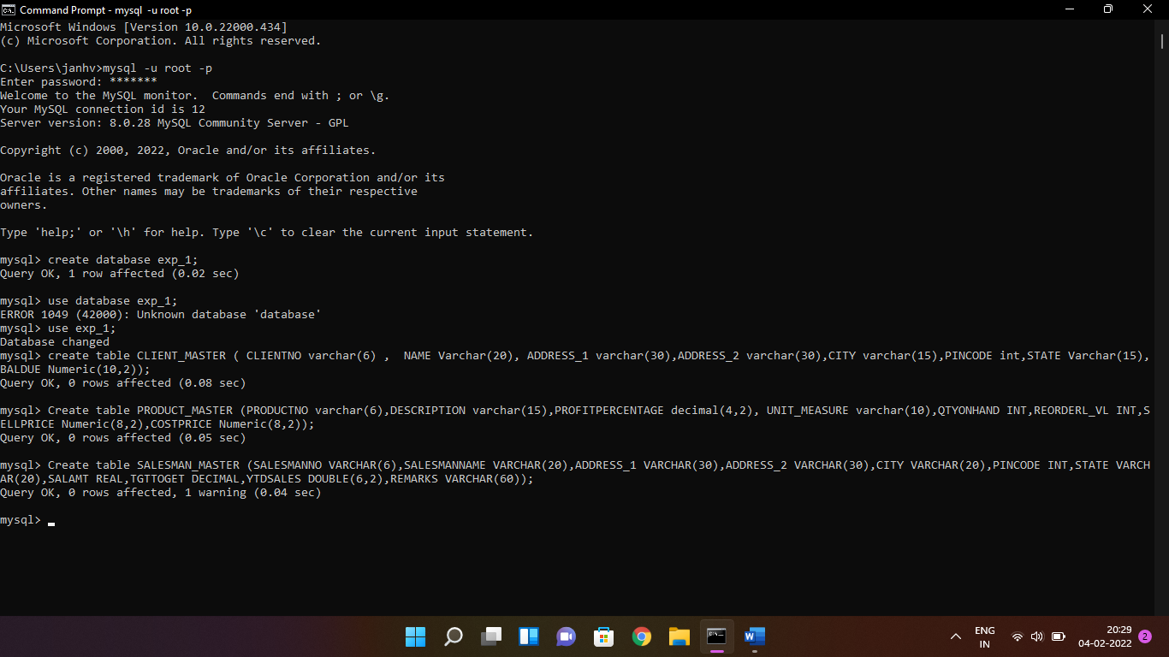

1. **Insert the following data into their respective tables:**
2. Data for **CLIENT_MASTER** table:

|  |  |  |  |  |  |
| --- | --- | --- | --- | --- | --- |
| Client no | Name | City | Pincode | State | BalDue |
| C00001 | Ivan bayross | Mumbai | 400054 | Maharashtra | 15000 |
| C00002 | Mamta muzumdar | Madras | 780001 | Tamil nadu | 0 |
| C00003 | Chhaya bankar | Mumbai | 400057 | Maharashtra | 5000 |
| C00004 | Ashwini joshi | Bangalore | 560001 | Karnataka | 0 |
| C00005 | Hansel colaco | Mumbai | 400060 | Maharashtra | 2000 |
| C00006 | Deepak sharma | Mangalore | 560050 | Karnataka | 0 |

1. Data for **PRODUCT**_**MASTER** table:

|  |  |  |  |  |  |  |  |
| --- | --- | --- | --- | --- | --- | --- | --- |
| Product  No | Description | Profit percent | Unit measure | Quantity  On  hand | Recorder  Level | Sell  Price | Cost  Price |
| P00001 | T-Shirt | 5 | Piece | 200 | 50 | 350 | 250 |
| P0345 | Shirts | 6 | Piece | 150 | 50 | 500 | 350 |
| P06734 | Cotton jeans | 5 | Piece | 100 | 20 | 600 | 450 |
| P07865 | Jeans | 5 | Piece | 100 | 20 | 750 | 500 |
| P07868 | Trousers | 2 | Piece | 150 | 50 | 850 | 550 |
| P07885 | Pull Overs | 2.5 | Piece | 80 | 30 | 700 | 450 |
| P07965 | Denim jeans | 4 | Piece | 100 | 40 | 350 | 250 |
| P07975 | Lycra tops | 5 | Piece | 70 | 30 | 300 | 175 |
| P08865 | Skirts | 5 | Piece | 75 | 30 | 450 | 300 |

1. Data for **SALESMAN_MASTER**  table:

|  |  |  |  |  |  |  |
| --- | --- | --- | --- | --- | --- | --- |
| **Salesman No** | **Name** | **Address1** | **Address2** | **City** | **Pin Code** | **State** |
| S00001 | Aman | A/14 | Worli | Mumbai | 400002 | Maharashtra |
| S00002 | Omkar | 65 | Nariman | Mumbai | 400001 | Maharashtra |
| S00003 | Raj | P-7 | Bandra | Mumbai | 400032 | Maharashtra |
| S00004 | Ashish | A/5 | Juhu | Mumbai | 400044 | Maharashtra |

*Input the details of members in the table made above,*

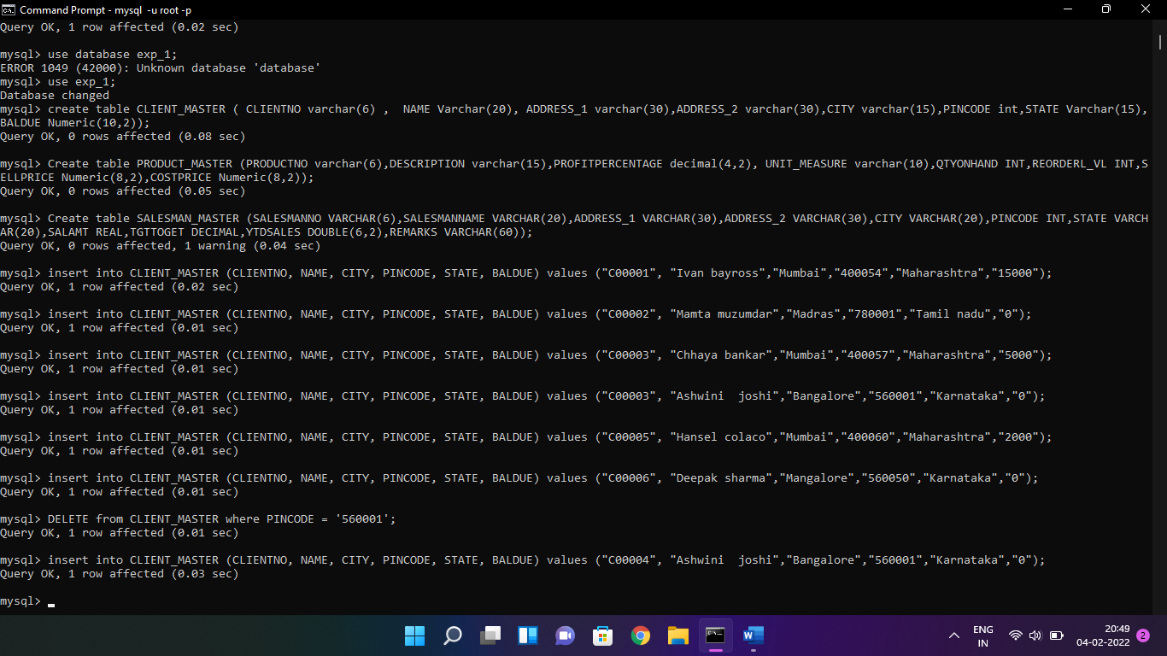

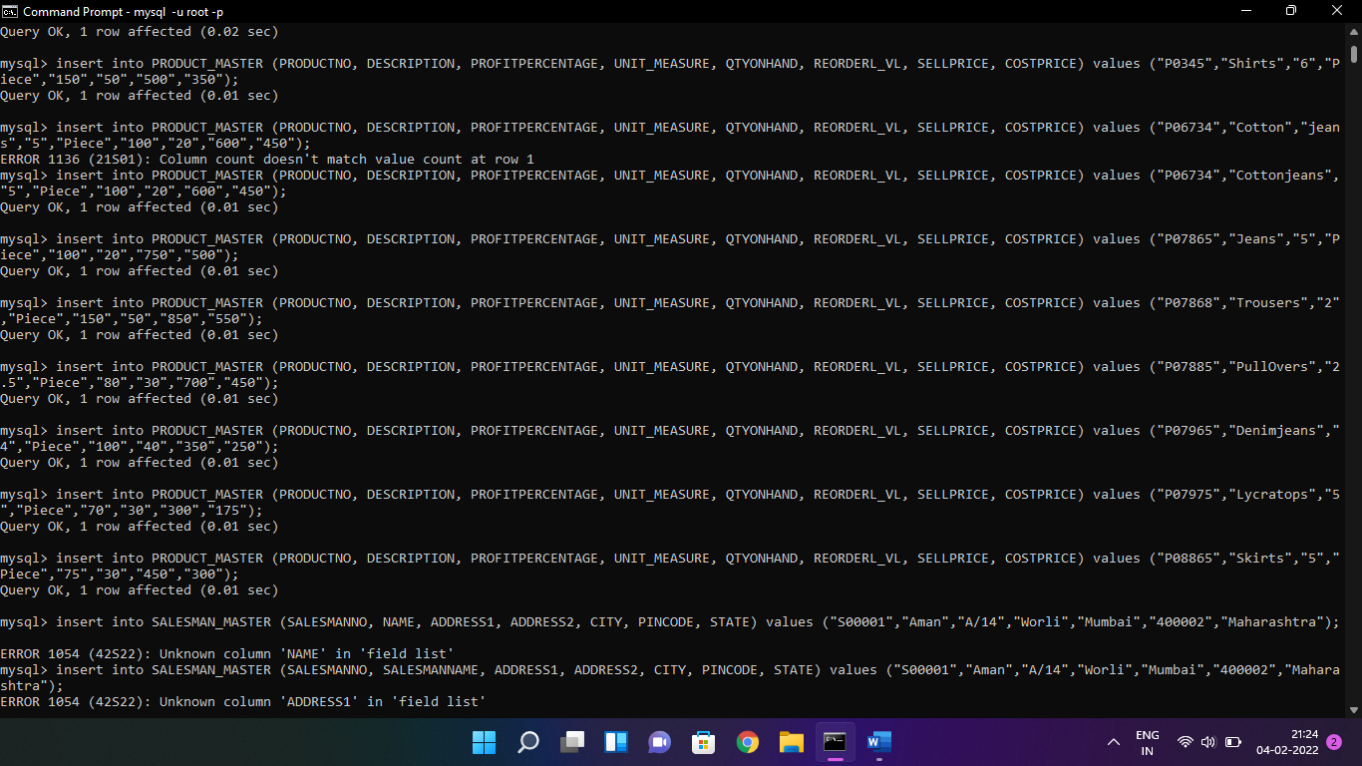

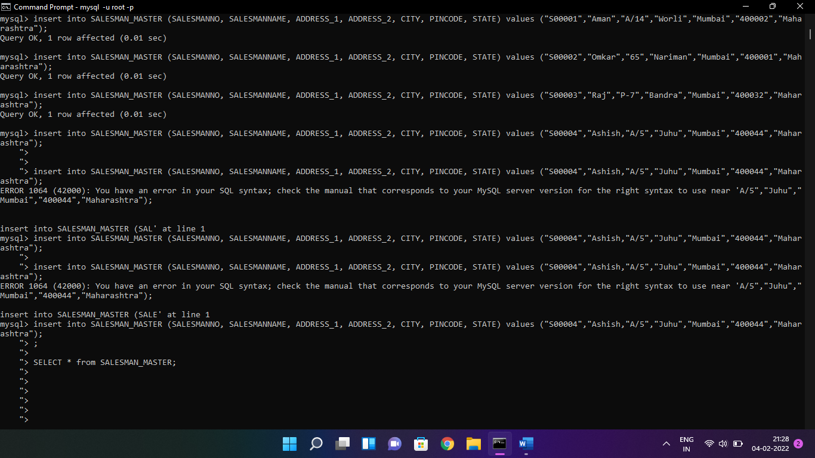

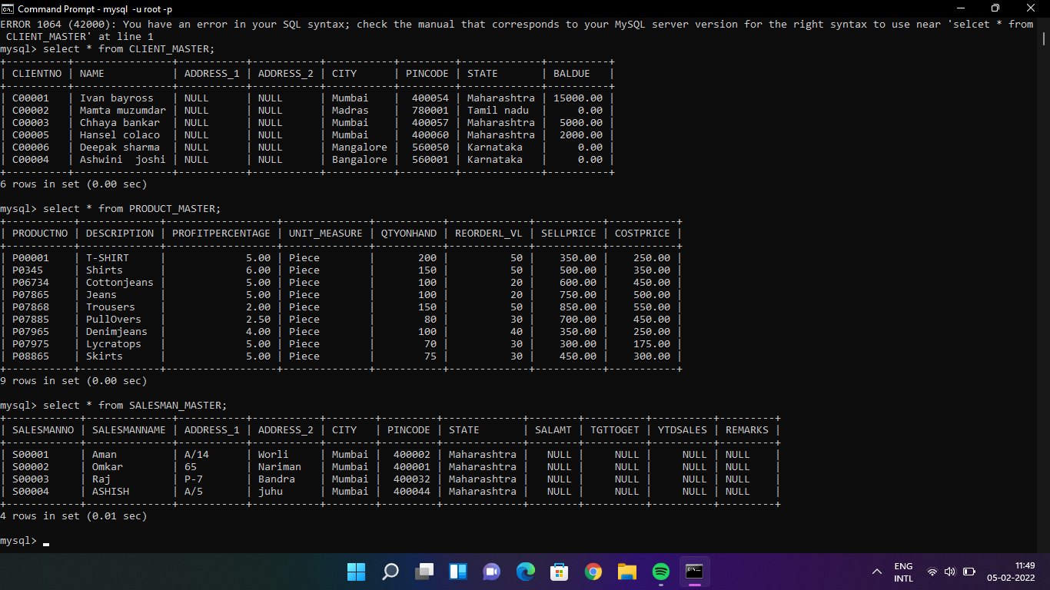

1. **Exercise on retrieving records from a table.**  
   a. Find out the names of all the clients.

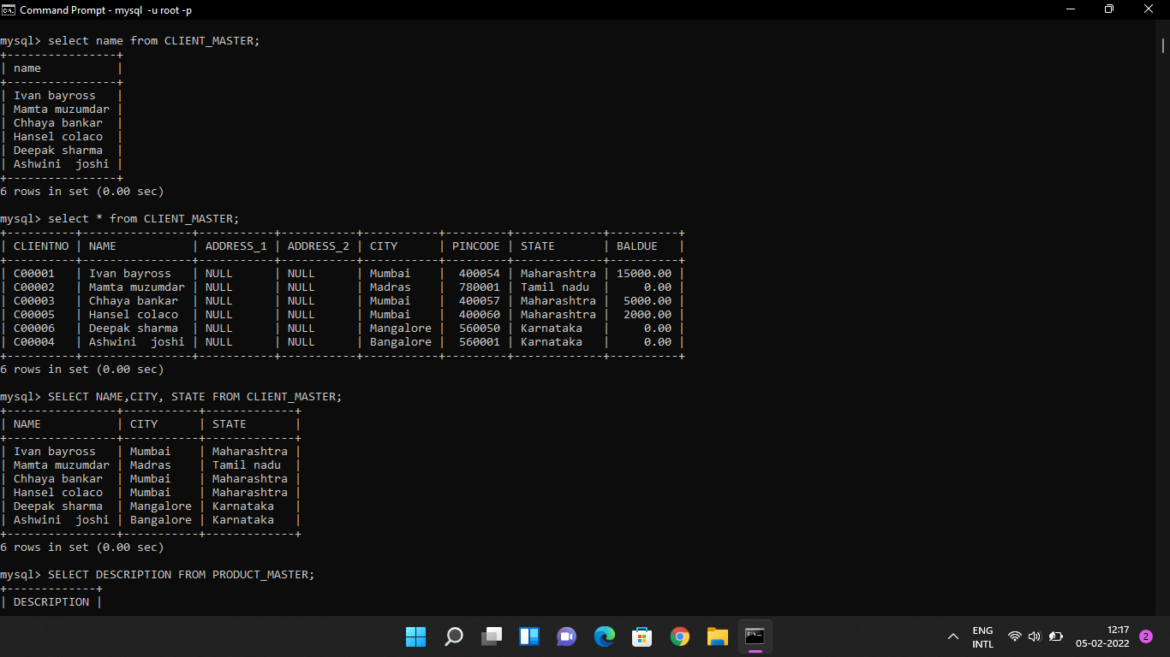  
b. Retrieve the entire contents of the Client_Master table.

**  
c. Retrieve the list of names, city and the state of all the clients.

**  
d. List the various products available from the Product_Master table.

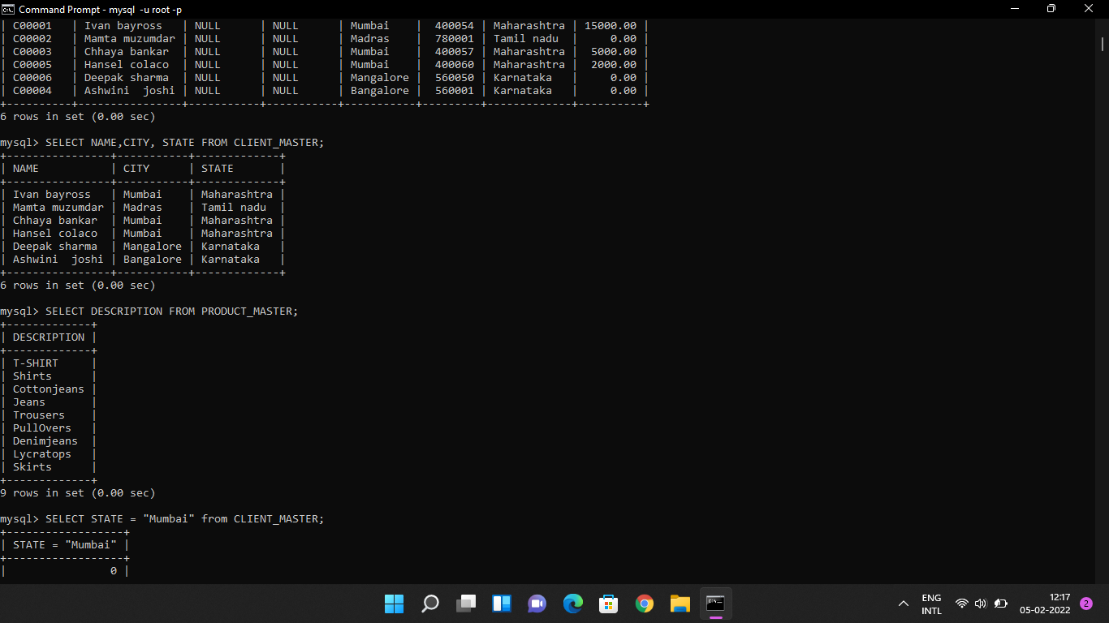  
e. List all the clients who are located in Mumbai.

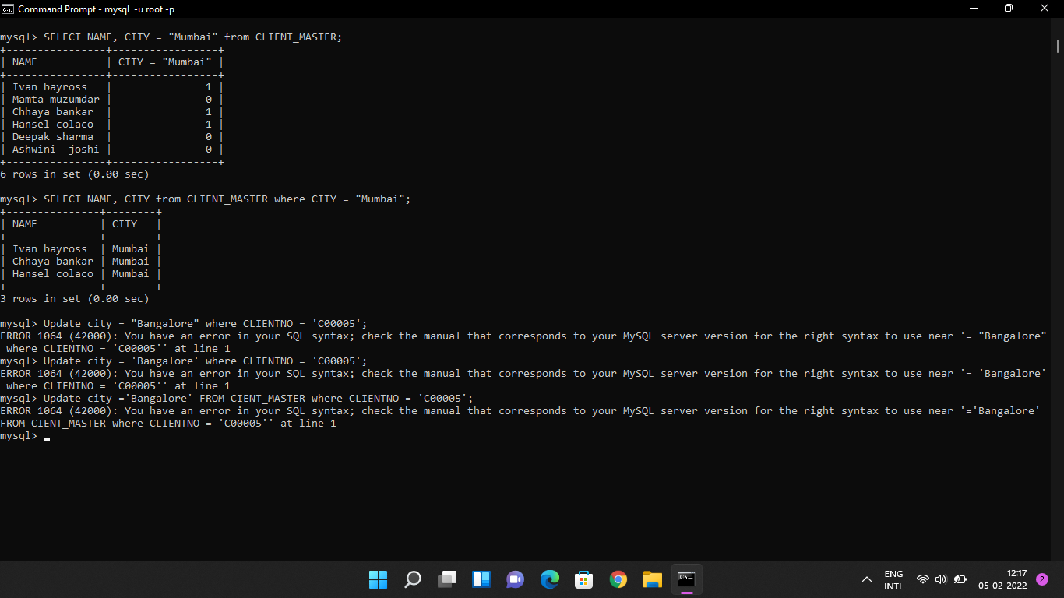  
f. Find the names of salesman who have a salary equal to Rs.3000.

*It will be null as there is no amount which has been filled in Salary*.

1. **Exercise on updating records in a table**  
   a. Change the city of ClientNo ‘C00005’ to ‘Bangalore’.

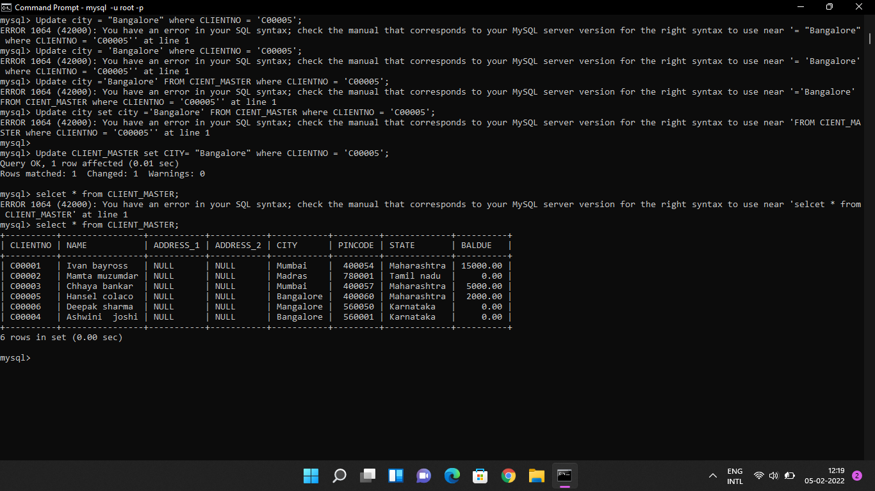  
b. Change the BalDue of ClientNo ‘C00001’ to Rs.1000.

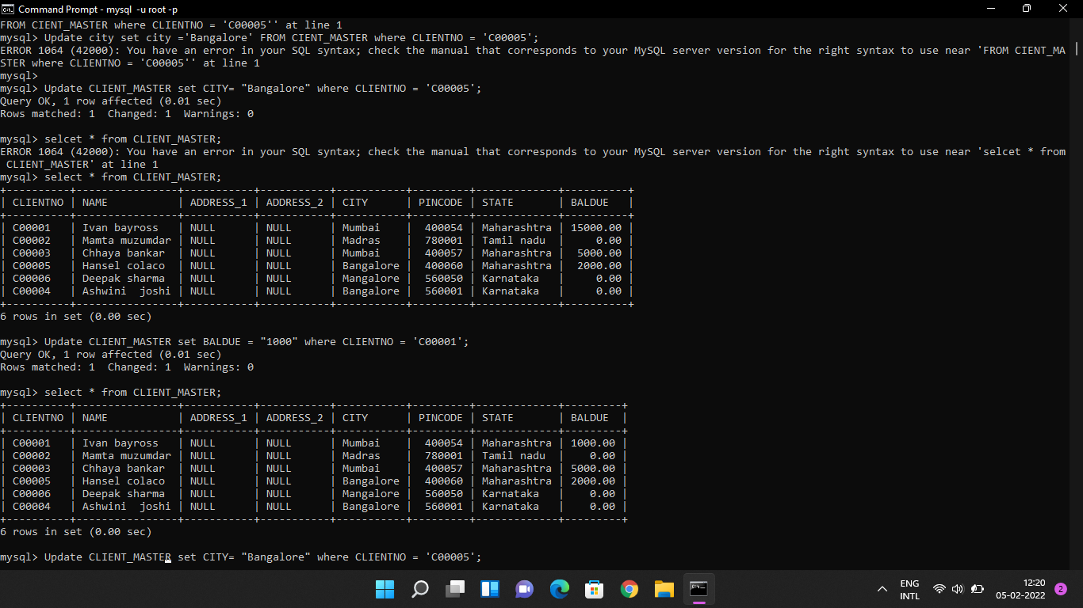  
c. Change the cost price of ‘Trousers’ to rs.950.00.

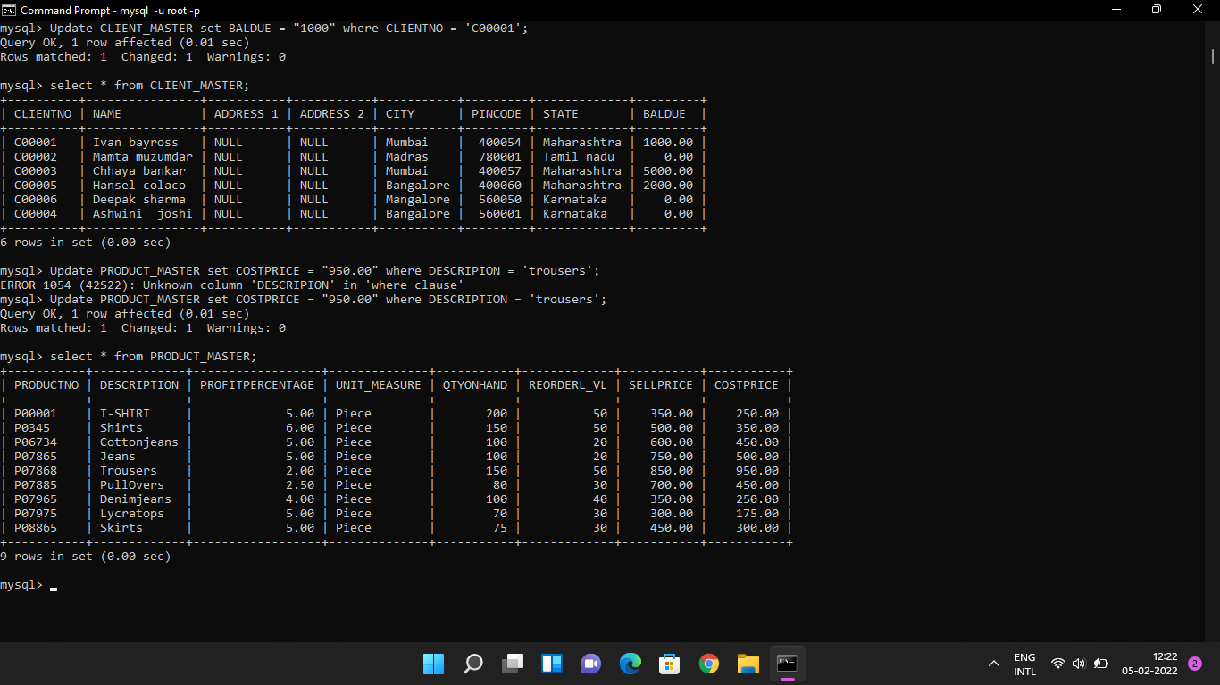  
d. Change the city of the salesman to Pune.

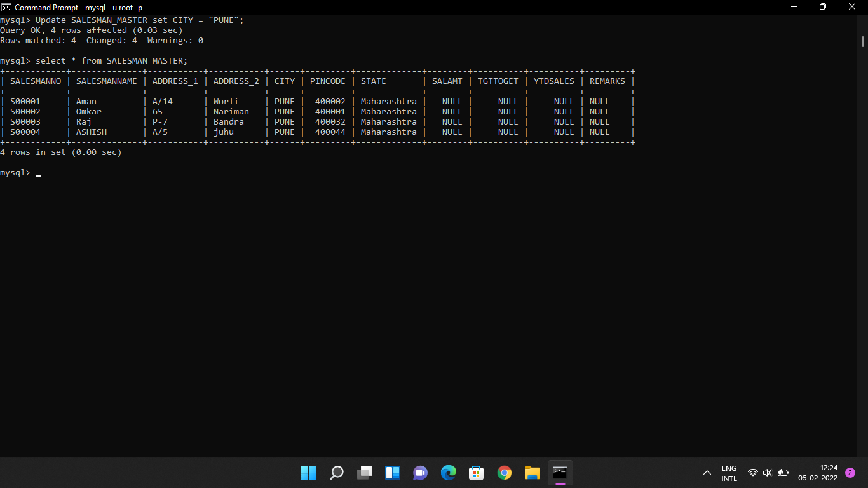

1. **Exercise on deleting records in a table**  
   a. Delete all salesman from the Salesman_Master whose salaries are equal to Rs.3500.

*There is no amount to be filled in salary mentioned above, so it will gives error or null.*

b. Delete all products from Product_Master where the quantity on hand is equal to 100.

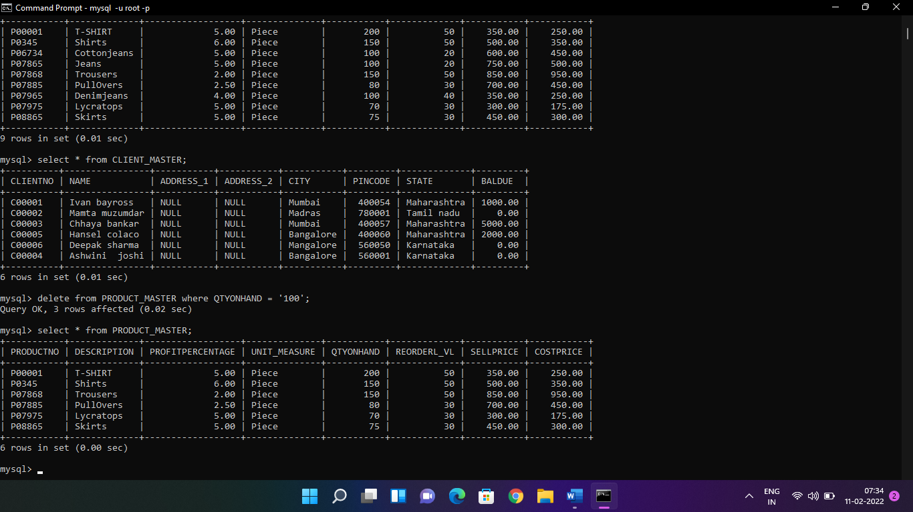

c. Delete from Client_Master where the column state holds the value ‘Tamil Nadu’.

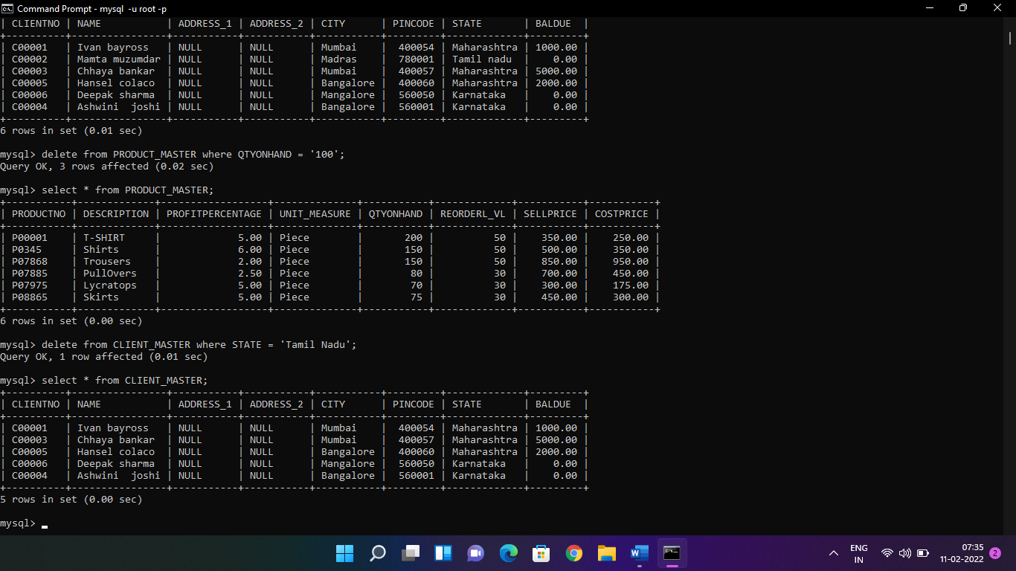

1. **Exercise on altering the table structure**  
   a. Add a column called ‘Telephone’ of data type integer to the Client_Master table.

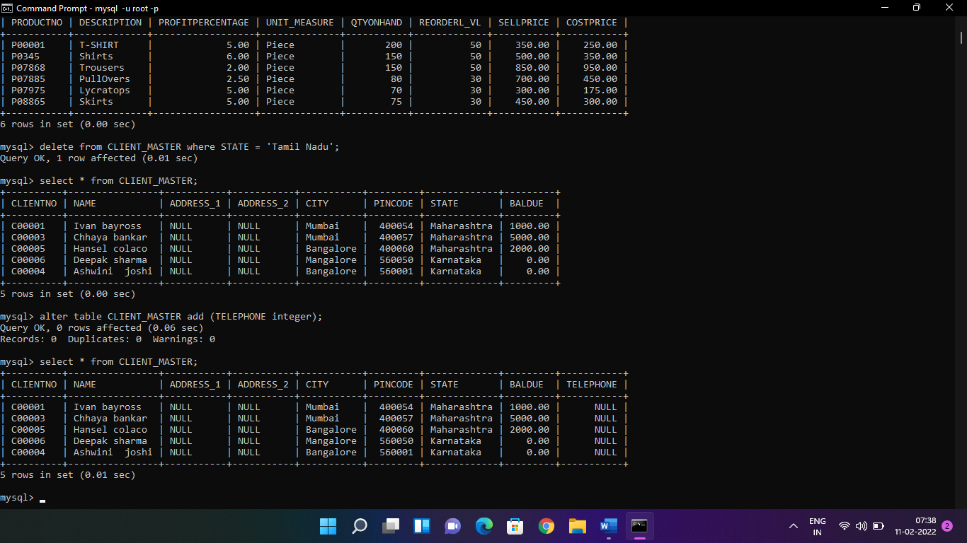  
b. Change the size off SellPrice column in Product _Master to 10, 2.

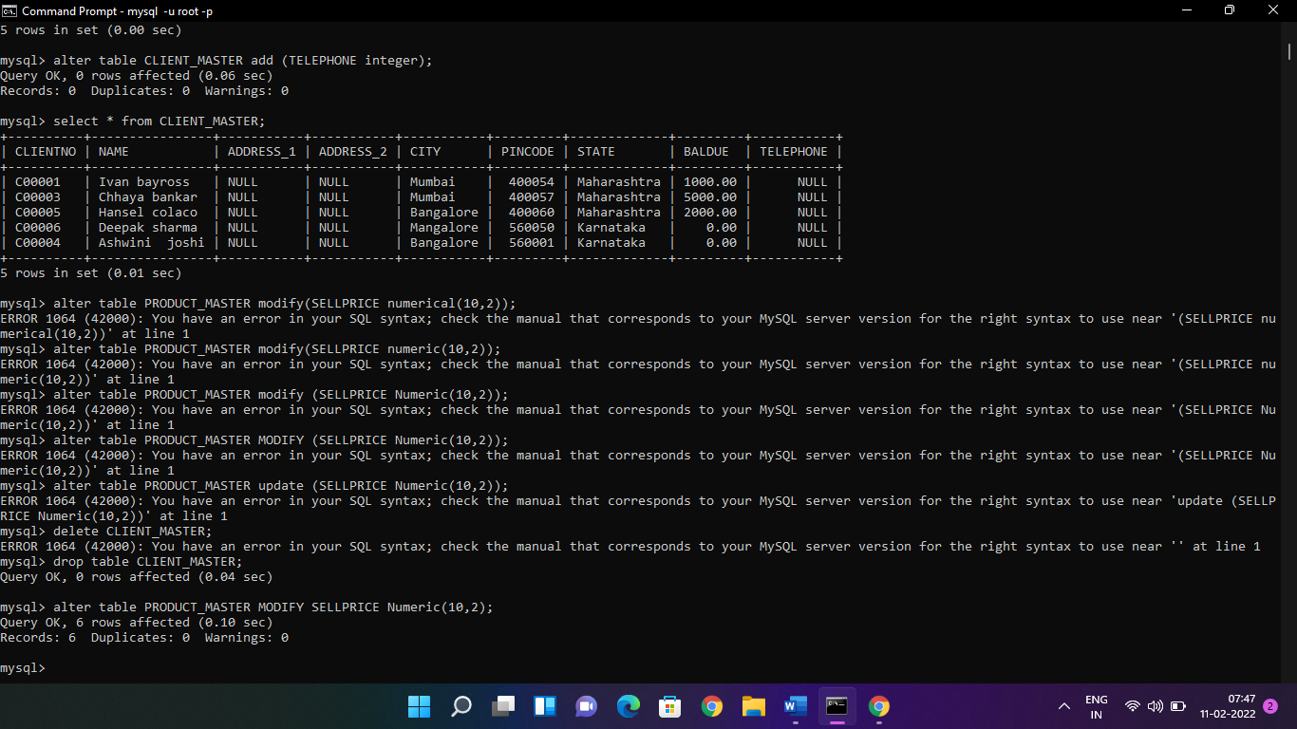

1. **Exercise on deleting the table structure along with the data**  
   a. Destroy the table Client_Master along with its data.

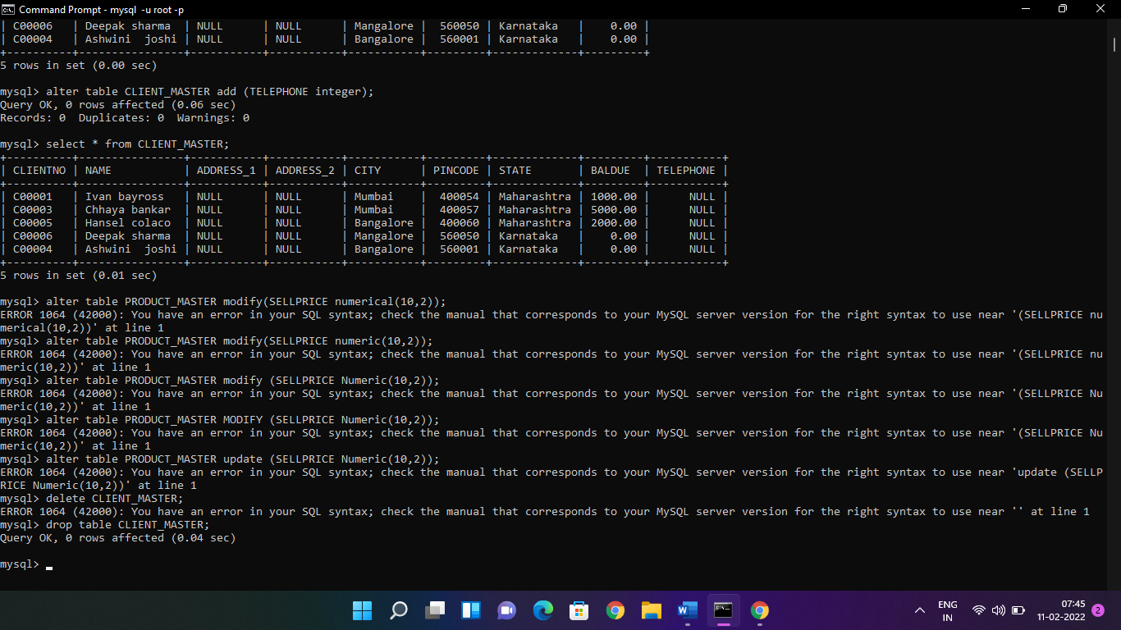

1. **Exercise on renaming the table**  
   a. Change the name of the Salesman_Master to sman_mast.

